International Conference on Unsaturated Soils 3 – 5 August 2018
Sponsorship Reply Form (Exhibition Booth)

To: UNSAT2018 Conference Secretariat
Geotechnical Centrifuge Facility
The Hong Kong University of Science and Technology
Clear Water Bay, Kowloon, HONG KONG
Tel: (852)23580216 Fax: (852)22430040 Email: stse@ust.hk

Our Company would like to sponsor for:

□ Exhibition booth HK$30,000.00
Includes:
  - a 6-feet table
  - a display panel that can hold two A0 size posters
  - one free registration for the conference

Sample of the booth:
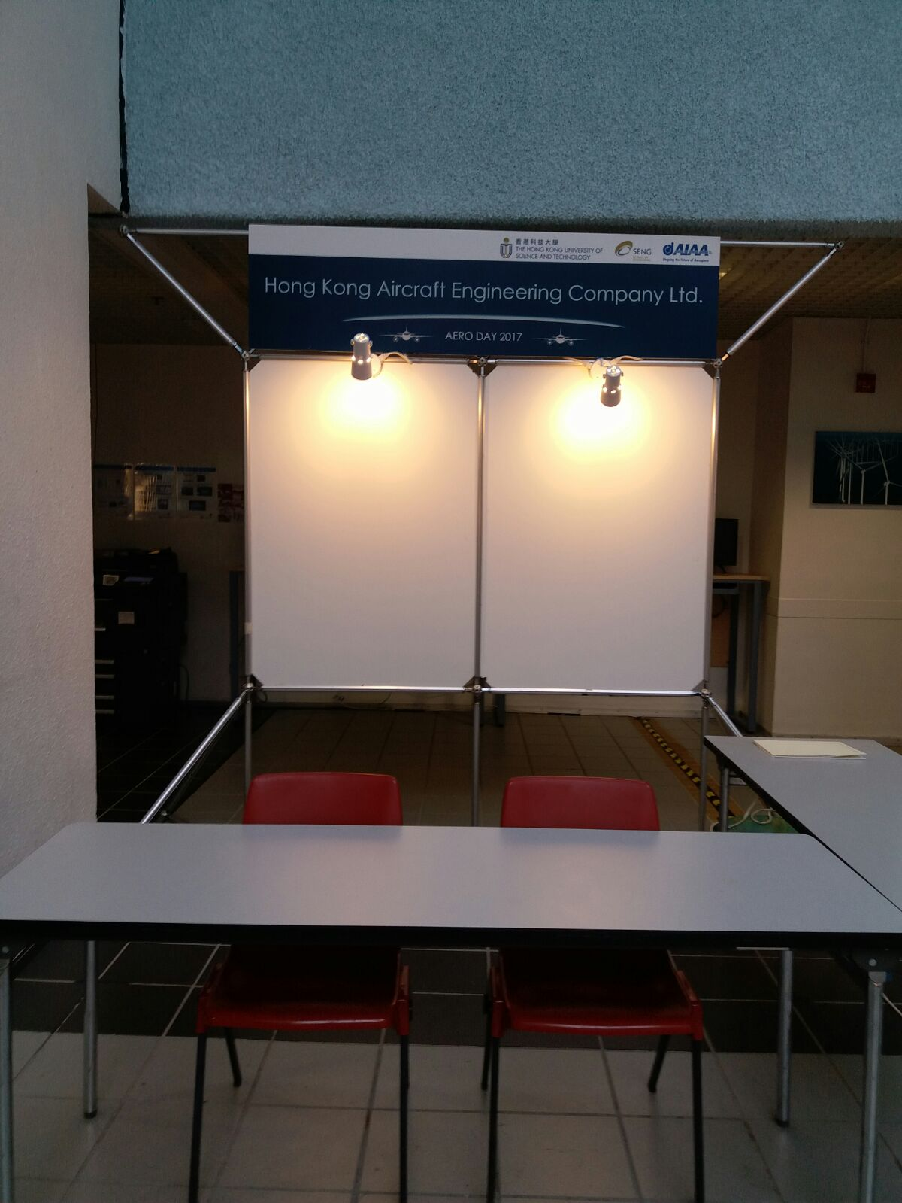

A crossed cheque / bank draft (no. _________) made payable to “The Hong Kong University of Science and Technology” for the sum HK$ ________________ is enclosed.

Name*: (Ir/Prof/Dr/Mr/Ms)
Organization:
Position:
Address
Telephone: |  | Fax No.: |  | Email:
Signature: |  |  |  | Date:

